SQL Beginner Practice Questions (Total: 30)
How to create a Products table in mysql
LOAD DATA INFILE '/path/to/productsTableSql.csv'
INTO TABLE products
FIELDS TERMINATED BY ','
ENCLOSED BY '"'
LINES TERMINATED BY '\n'
IGNORE 1 ROWS
(ProductID, Name, Price, Rating, Category, Discount);

Sample table Employee table is here
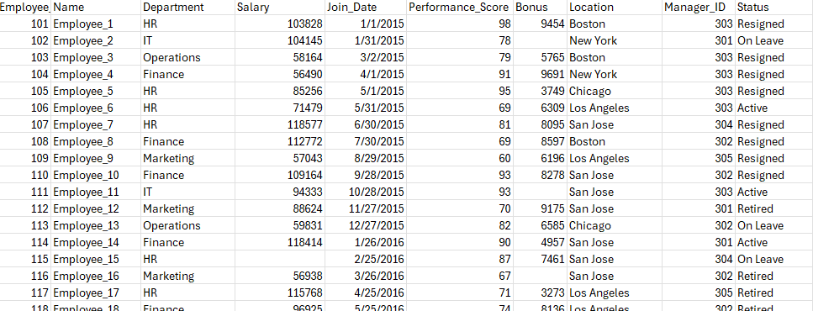
Basic Filtering, Logical Operators, IN, BETWEEN, LIKE, Arithmetic, and Sorting
- Retrieve all employees who work in the "Sales" department.
- List employees whose salary is greater than 50,000.
- Show employees who joined after 2020-01-01.
- Get employees who are from either "New York" or "Chicago".
- List employees who are not in the "HR" department.
- Show employees with a bonus between 1000 and 5000.
- Retrieve employees whose status is "Active" and salary is more than 60,000.
- Find employees who are either in "Marketing" OR have a performance score of 9 or above.
- Show employees who do not have a bonus assigned (bonus is NULL or 0).
- Find employees whose names start with 'A'.
- List employees whose names contain 'son'.
- Get employees whose department name ends with 'ing'.
- Get the top 5 highest-paid employees.
- List employees sorted by Join_Date in ascending order.
- Show employees ordered by performance score (highest to lowest).
- Display each employee’s total compensation (Salary + Bonus) as Total_Compensation.
- Calculate a 10% bonus on salary and show it as Estimated_Bonus.
- Find employees in departments 'Finance', 'Sales', and 'IT'.
- Show employees whose joining date is between '2018-01-01' and '2020-12-31'.
- List employees who don’t have a manager (Manager_ID IS NULL).

Grouping and Aggregation
- Count the total number of employees.
- Find the average salary of all employees.
- Find the maximum and minimum bonus.
- Count the number of employees in each department.
- Find the total salary expense per department.
- Find the average performance score per department.
- Show the highest-paid employee in each department.
- Count how many employees are in each location.
- Find departments with more than 5 employees.
- Get the average bonus of employees who are active.

VamsiKundeti Vamsi is inviting you to a scheduled Zoom meeting.

Topic: VamsiKundeti Vamsi's Zoom Meeting
Join Zoom Meeting
https://us05web.zoom.us/j/83367027344?pwd=6AgC6jRzgr9Ic7O7VSCQbk2n9icAWO.1

Meeting agenda
https://docs.zoom.us/agenda/doc/a58a1259-3bba-4608-8dc1-bca02bf0c655

Meeting ID: 833 6702 7344
Passcode: inma5Z

Join instructions
https://us05web.zoom.us/meetings/83367027344/invitations?signature=ilD0cTAZ7UO_HlScihG5bSpbal31mQM6o7oJcBi0sio

